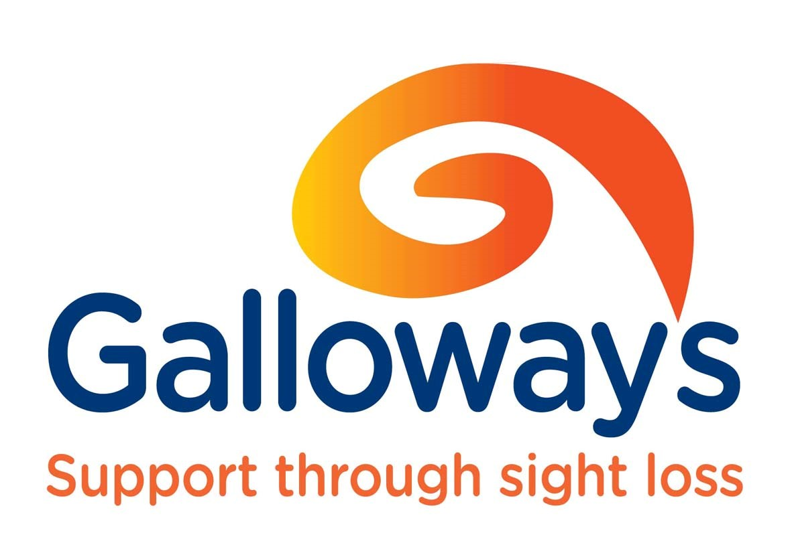

1a Farrington Street
Chorley
PR7 1DY

What’s Going On
Guide

September 2020

For advice please phone 01772 230527 or the general office number 01772 744148

Email: enquiries@galloways.org.uk

Registered Charity Number 526088

A word from Natalie Walker, Galloway’s Communications Officer

Galloway’s Eye
After a short break, The Galloway’s Eye is back - and it is bigger and better than ever!
You can listen an interview on how social distancing affects people with sight loss, find out more about the new Be My Eyes app, and catch up on a round-up of our amazing guests on James and Andrew’s Zoom sessions. We even have an interview with the late Dame Vera Lynn, unearthed from a few years ago.
If you have not already had a listen, you can find it on our Alexa skill, as well as on the Watch and Listen section of our website www.galloways.org.uk.
At this stage, it is not available on CD, but once the studio and office are back in use, we can look at sending it out again on CD or possibly USB.
As we had so much great content, the What’s Going On Guides are now separate recordings, which are also available on our Alexa skill and website.

Fundraising
Did you know our chairman, Simon Booth, and his family are taking on a mammoth challenge to raise money for us?
They have collectively signed up to the Great North Run Solo and have set themselves a target of running or walking a combined 1,000km by September 13.
You can make a donation via Virgin Money Giving website: https://uk.virginmoneygiving.com/Team/TheBoothFamily1000kNorthenRun
You can also read the full story in the news section of our website.

Hello from staff
We hope you are continuing to keep well during this difficult time, and though our office is closed, you can still ring Amanda or Stuart for advice on 01772 230527 or the general phone number 01772 744148.
Amanda is on furlough until September, and Nia is working two days a week (Tuesday and Wednesday) on low vision assessments. There is still no date for our office opening but you can always contact us if you need anything from the Resource Centre.
Take care of yourselves.
Best wishes from all the Chorley team.

Let’s start a members’ page!
We have been sending out the ‘What’s Going on Guide’ during this very strange time and hope that we have been keeping you updated on the innovative ways we are working.
We have been including recipes, poems, riddles plus lots more.
However, we would like to know what you have been doing during the lockdown. Please share any tips, stories, poems or anything to make people smile and brighten up their day.
Have you used talents you forgot you had?
Have you any tips you would like to share?
Have any funny stories you would like to share?
We would love to hear some jokes!
We look to hearing your stories so please get in touch with your local team.

Local Contacts
The Macular Society Local Support Group runs a telephone group chat once a month between 1pm and 2pm with Eileen Astley, Chair of Chorley Support Group
The phone number to dial in is: 01264 560517 followed by the
PIN: 1
Please contact Eileen on 01257 277262 for further information
*Latest News* TV Licence Fee Reduction
If you are registered blind (severely sight impaired) then you are entitled to a “blind concession TV Licence” which gives you 50 per cent off the cost of your TV Licence. Unfortunately, you are not entitled to this if you are registered as partially sighted (sight impaired).
The blind concession TV Licence covers anyone who lives with you, as long as the licence is in your name. If your licence is in someone else’s name, then you can change this and then claim the reduction.
If you would like more information then call TV Licensing on 0300 790 6117 or visit tvlicensing.co.uk/blind.

Important changes to the free TV Licence if you are aged 75 or over
After 1 August 2020, anyone over 75 and not claiming pension credit (or able to apply for the discount noted above), will have to pay the full licence fee.
If you are over 75, and currently have a free licence, you will be covered until 31 July 2020. You don't need to do anything now. TV Licensing will contact you before 31 July to let you know what you need to do.
If you would like more information then call TV Licensing on 0300 790 0368 or visit tvlicensing.co.uk

Outreach
Galloway’s service team now offers outreach support to the over 50’s who are isolated and experiencing loneliness. This new role will ensure that Galloway’s can reach more people in their local community. The same range of services is provided including: access to equipment and assistive technology, information, advice and guidance, confidence building and emotional support.
So if you – or someone you know – needs help to cope with the practical and emotional impact of sight loss, contact Caroline Cameron, Outreach Sight Loss Advisor, on 01772 744148 or caroline.cameron@galloways.org.uk.

Be My Eyes
You now have another way of communicating with our sight loss advisors, as we have joined Be My Eyes, which is a globally used free app that connects blind and partially sighted people with sighted volunteers for visual assistance through a live video call. You can download the app from the App Store and the Play Store by searching for “Be My Eyes”. Once you have installed the app and created your account you can get our help by locating Galloway's in the Specialized Help menu. Then you can make the call – your sight loss advisors are ready and waiting!

Galloway’s Talking Together
This telephone based service enables users to talk with a group of others, using only their landline or mobile phone.
The telephone number for the Talking Together session is classed as a local call, so if you have ‘anytime calls’ on your landline, or ‘unlimited minutes’ on your mobile then you will not be charged for the call. No access to the internet is required.

The phone number and pin number are the same every time, so this makes it easier to use and store.
Phone number: 0330 336 0036
PIN: 13 58 28

Talking Together (open to all):
All events start at 2pm unless indicated otherwise. Please ensure that you ‘arrive’ on time!
Every Monday Quiz – Join in and test your general knowledge.
Every Tuesday at 10am - a light-hearted look at the good news stories from around the world. This is an open group for anyone to join.

Thursday 10th September - “A History of Lancashire Place Names” – a talk by Anthony Poulton-Smith, freelance journalist and author of 65 books, numerous articles, crosswords and puzzles
Tuesday 15th September – talk by Mike Bailey, Development Manager for Christopher Grange / Bradbury Fields in Liverpool on Esme’s Friends Telephone Support Group for people with Charles Bonnet Syndrome.
Thursday 17th September – Exploring French/German Regions by a tutor from Lancashire Adult Learning: this course will explore one of the following options different regions, famous people (artists), festivals & celebrations, culinary specialities or exciting destinations. Individuals can join in with the discussion, share their own personal knowledge or learn more about the country.
Thursday 24th September - “Life through the rear view mirror” - a humorous and entertaining talk by Ron Hutchinson about his life working as a chauffeur to prominent Lancastrians, particularly Lord Leverhulme

Please note: there will be no Yoga Nidra Meditation with Helen this month due to poor take up last month

Alexa Skill
Our exciting new Alexa skill is now live! You can now listen to the latest talking news service, James Coulton Armchair exercises, hear information about eye conditions and eventually when we’re back up and running, hear about Galloway’s events that are happening near you. You can access the skill by simply asking Alexa to ‘Enable Galloway’s Support through Sight Loss’.
Then you have the skill. When you want to use it, you say. ‘Alexa, open Galloway’s support through sight loss.’
Eye Clinic Liaison Officer (ECLO) Update:
I am due back in clinic in September; however, I do not know what days I am where yet, as I will be getting used to the clinics’ schedules and guidelines.
Opticians are open and are available to book appointments, so give them a call. Also, some routine eye clinic appointments are now starting back up again, however there is of course a back log to get through. Some eye clinic appointments may still be carried out over the phone or via video. If you have any issues with a video or telephone appointment, let me know I can perhaps act as an advocate.
Patient Transport is back up and running via NW Ambulance Service, so if you have an upcoming hospital appointment and require transport give them a call on 0800 032 3240 – usually they ask to call 2-3 days before your appointment.
If you have any concerns about your vision or hospital appointments, please contact me and I will discuss support.
Glen Sheader
Eye Clinic Liaison Officer (ECLO)
07498 369881
glen.sheader@nhs.net

Get Active
Join James Coulton every Friday at 2pm for a Get Active chat and catch up session on Zoom. The link is posted in the Get Active Facebook group every Thursday.
Our ‘return to walking’ groups following lockdown received some great feedback and a video can be seen on our YouTube channel (Galloways Blind).
We will be running more walks in September but places are severely limited due to the guidelines covering groups. To book a place, please call 01772 744148 and ask to speak to James.
Please check out our ‘Galloways Blind’ YouTube channel which has lots of content about walks, nature, gear guides, and exercise which are also uploaded to the get active group. If you have any ideas on future videos or ideas on what you would like to see then please get in touch. James.coulton@galloways.org.uk

Talking News
We are managing to put out a reduced Talking News service, which is currently available on our Alexa skill, website, British Wireless for the Blind Sonata service and their Talking News App as well as on the Lancashire Post website.

Talking Tech
Andrew is available to answer your technology enquiries. He can talk to you over the phone or video chat! In some cases Andrew can also provide remote support by connecting to your device. Andrew can provide you with individual tailored training and support. Andrew can be contacted via:

Telephone: 01772 230531
E mail: Andrew.Coleman@galloways.org.uk
Facebook & Messenger, search for: Andrew Coleman – Talking Tech
You can also search for and join the “Galloway’s Technology Group” on Facebook. This is a private group for the Galloway’s community and features articles and discussion around all things tech. It’s a great way of keeping in touch with everyone, whilst keeping up to date.

Talking Tech Social @ 3 – Every Tuesday drop in anytime 3pm - 5pm

Andrew and the team will be live on Zoom every Tuesday from 3pm until 5pm for Talking Tech Social @ 3.
This is a laid-back drop in and out Zoom session, where you ask us tech questions, get some tips and tricks or just to find out what’s hot in the world of all things tech.
Andrew and the Galloway’s volunteers will be available to demonstrate and share their knowledge on products such as:

• Apple iOS
• Android
• Synapptic
• Apps
• Apple and Microsoft operating systems
• Wearable Technology such as OrCam
• Electronic Magnifiers
• Text to speech readers

And so much more…

For more information, and to join the mailing list, please email: Andrew.coleman@galloways.org.uk or speak to one of our sight loss advisors. You will then be sent an email every week with instructions to join by Zoom video call.

To join the meeting by telephone every Tuesday, please use one of the following local numbers (Calls charged at local rate. Please check your call package and remaining minutes).

0131 460 1196
0203 051 2874
0203 481 5237
0203 481 5240

Once connected, you will be prompted to enter the following Meeting ID using your phone’s number pad: 885 9496 4436

We look forward to seeing you.

Tech Talk @ 3 – Every Thursday 3pm – 4pm
Andrew will also be hosting the popular “Tech Talk @ 3” when he will be joined by a special guest from the world of all things technology. Every week offers something different covering a wide range of topics. There have already been some fantastic speakers with lots more to come. You can join us by telephone or video chat via Zoom. It’s a great way to keep in touch with everyone. For more information and to join the mailing list please email: Andrew.coleman@galloways.org.uk or speak to one of our sight loss advisors. You will then be sent an email every week with instructions to join by Zoom video call.

If you are unable to join any of the “Tech Talk @ 3” events, don’t worry as you will be emailed a link so that you can watch the event again via YouTube. You can also find the link on the “Galloway’s Technology Group” page on Facebook or by searching for “Galloway’s Blind” on YouTube.

Please note! It will not be possible to join after 3:10pm. You are welcome to join before 3pm to make sure you connect successfully. When joining you will be placed in the Waiting Room before being admitted to the event.

To join the meeting by telephone every Thursday, please use one of the following local numbers (Calls charged at local rate. Please check your call package and remaining minutes).

0131 460 1196
0203 051 2874
0203 481 5237
0203 481 5240

Once connected, you will be prompted to enter the following Meeting ID using your phone’s number pad: 843 3979 7220

We look forward to hearing from you

And finally, a word from Holly Atkinson, Galloway’s Lottery and Legacy Fundraiser:

Did you know…that we are able to support 1 in 4 people thanks to people kindly leaving us a gift in their Will?

Join the Galloway’s Lottery to help us continue supporting people living with sight loss. Entry is just £1 a week and you could be in with a chance of winning the jackpot prize of £25,000! Speak to a member of the team today if you would like more information.

Galloway’s is a local charity supporting thousands of blind and partially sighted people across Sefton and Lancashire.
If you are affected by sight loss, we are here to help. Please get in touch.

